Parking Management System in Assembly Language
Project Title:
Parking Management System in Assembly Language
Group Members:
• Iqra Ashraf – 24K-0952
• Samiya Khan – 24K-0768
• Aseelah Masood – 24K-0881
Submission Date: 24 Nov 2025

1. Executive Summary
Overview:
This project presents the development of a Parking Management System using 8086 Assembly Language. The system allows users to select different vehicle types, maintain counts, calculate total revenue, display records, and reset data. The purpose was to demonstrate how low-level programming can handle input and output, arithmetic operations, and data management without high-level language features.
Key Findings:
• Assembly Language effectively manages input and output through INT 21h.
• Logical operations such as branching, looping, and counting can be implemented efficiently.
• The final system performs all required parking operations including fee calculation and record resetting.
• The project significantly enhanced understanding of low-level computation and hardware interaction.

2. Introduction
Background:
Assembly Language offers direct control over hardware, making it ideal for understanding core computational processes. This project demonstrates how a real-life application, a parking management system, can be implemented using basic Assembly instructions. It highlights low-level programming concepts relevant to system programming and understanding machine architecture.
Project Objectives:
• Design a menu-based parking management system.
• Implement vehicle counters and fee calculations using memory variables.
• Use DOS interrupt services for input and output.
• Demonstrate logic flow through loops, jumps, and conditions.
• Provide a functional system that mimics a small-scale parking environment.

3. Project Description
Scope:
The project includes:
• Menu with options for Rickshaw, Car, Bus, Show Record, Delete Record, and Exit
• Fee calculation and vehicle counting
• Total revenue display
• Record deletion through a reset feature
• Input validation and clean user interaction
• Use of Assembly procedures and INT 21h
Excluded from the project:
• Graphical User Interface (GUI)
• File storage or permanent data saving
• Vehicle registration inputs
• Advanced numeric or floating-point operations
Technical Overview:
Tools and technologies used:
• Visual Studio 2022 for writing the Assembly code
• Emu8086 for assembling and executing the program
• Notepad++ or VS Code for additional editing (optional)
• Microsoft Word or PowerPoint for documentation and presentation
The program uses 8086 Assembly with DOS Interrupt 21h for all input and output operations.

4. Methodology
Approach:
The team followed an iterative development method. The project progressed through research, design, implementation, and testing phases. Weekly meetings ensured alignment, and tasks were divided into manageable portions. As modules were completed, they were integrated and tested to ensure proper functionality.
Roles and Responsibilities:
• Iqra Ashraf (24K-0952): Designed the main menu, handled input and output routines, managed display formatting, and contributed to debugging and system integration.
• Samiya Khan (24K-0768): Implemented arithmetic logic including vehicle counters, fee calculations, and the Show Record functionality.
• Aseelah Masood (24K-0881): Implemented the Delete Record function, handled error messages, and contributed to final testing and documentation.
All members contributed to coding, testing, and documentation preparation.

5. Project Implementation
Design and Structure:
The system is menu-driven. The main program displays the menu and waits for a keypress. Each menu option directs control to a specific procedure. Memory variables store vehicle counters and total revenue. Registers handle calculations, and interrupts manage screen output and key input.
Functionalities Developed:
• Parking a rickshaw
• Parking a car
• Parking a bus
• Auto-incrementing vehicle counters
• Calculating and updating total parking fees
• Displaying number of vehicles and total revenue
• Resetting all records
• Handling invalid user input
Challenges Faced:
• Managing numeric conversion for screen display
• Handling multi-digit arithmetic without built-in operators
• Debugging incorrect jump statements
• Maintaining correct register and stack usage
These issues were resolved through step-by-step debugging in Emu8086 and reorganizing code modules for clarity.

6. Results
Project Outcomes:
• A fully functional parking management program developed in Assembly Language
• Correct handling of counting, addition, and record display
• Smooth menu navigation and user interaction
• Reset feature that clears all stored data accurately
• Logical flow that reflects low-level programming structures effectively
Screenshots and Illustrations:
• Screenshot of main menu
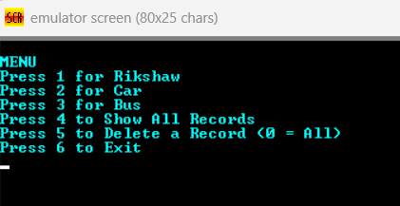
• Screenshot of entering vehicles
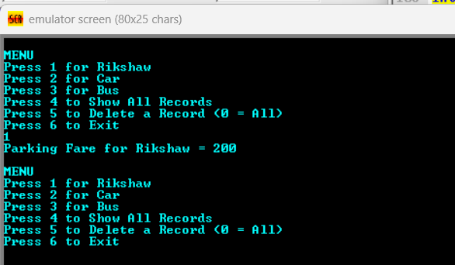
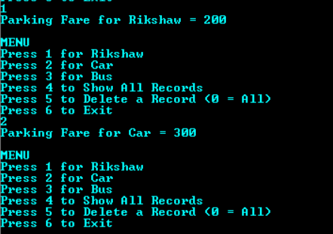
• Screenshot of Show Record output
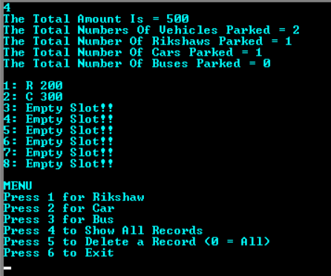
• Screenshot of Delete Record confirmation
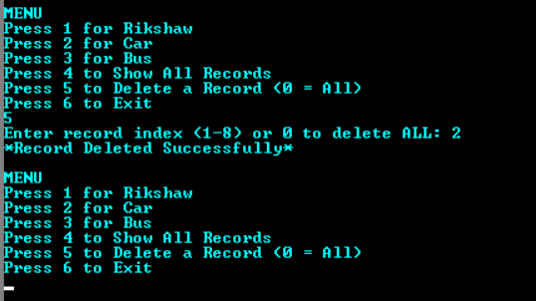
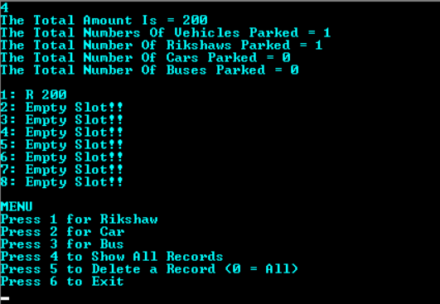
Testing and Validation:
Testing involved executing each menu option multiple times, verifying vehicle counters, confirming fee calculations, checking correct record display, testing the reset functionality, and validating behavior for incorrect inputs. The system performed correctly for all test cases.

7. Conclusion
Summary of Findings:
The Parking Management System meets all objectives outlined in the proposal. It shows how Assembly Language can be used to create a functional and interactive application involving data manipulation, logic flow, and user control. The system records vehicles accurately, computes revenue, and resets data as required.
Final Remarks:
This project strengthened our understanding of low-level programming and hardware interaction. It enhanced debugging skills, attention to detail, and understanding of how simple systems operate at the machine level. The work demonstrates the importance and complexity of Assembly Language in system development.

